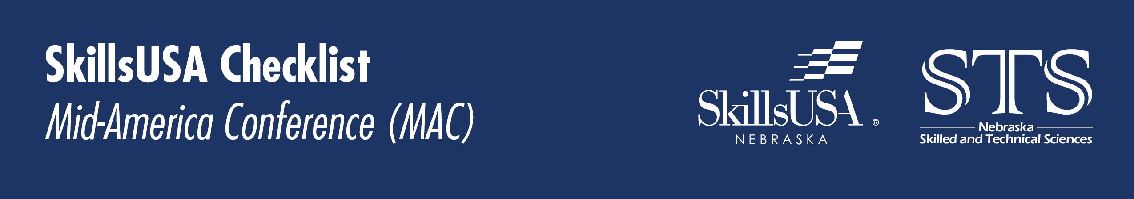

This is a fantastic conference designed to train local chapter officers.
Typically, this conference is on the 4th weekend of October running Wednesday evening thru Sunday afternoon. (Travel days Wednesday and Sunday afternoon)

September
☐ Identify officers and key leaders in your chapter.
☐ Recruit those key leaders to attend MAC.
☐ Fundraise for MAC – this conference is a high-level leadership development conference. (Estimated cost per person )
☐ Communicate with coaches and band director about shared students’ participation. Ideally student stay the entire time at MAC, but conflicts do happen.
☐ Arrange any logistics surrounding student conflicts.
☐ Line up transportation for MAC. We will use transportation throughout the event. If we can have access to your transportation throughout the week to move students to projects offsite it will keep costs down for the conference.
☐ Verify your school’s policy on transporting students and staff from different schools.
October
☐ Register for MAC.
- Visit skillsusanebraska.org > Events Tab > Mid-America Leadership Conference for event and hotel registration information.
☐ Finish fundraising or collect any payment for MAC.
☐ Pay for MAC.
☐ Attend MAC!

