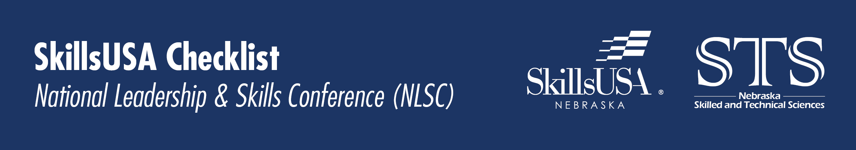

April
☐ Win a SkillsUSA National Contest at SLC
☐ Fundraise for NLSC.
☐ Send out a press release about SLC Performance
☐ Fill out school district forms & get permission for out-of-state travel.
☐ Have SLC Champions present to school board.

May
☐ With authorization from state director register for NLSC.
☐ Fundraise for NLSC.
☐ Planes, Trains, [Buses,] & Automobiles: Line up transportation for NLSC.
☐ Fill out room assignment forms.
☐ If wanting to share a room with another school, fill out the room sharing form.
☐ Print & pay invoice:
Send invoice and check payable to SkillsUSA Nebraska to:
Grafton Associates Attn: Denise Winters
5935 S 56th Street, Ste A
Lincoln, NE 68516

June
☐ Double check tool list and contest dress.
☐ Register for SLC, registration general opens early January.
☐ Check in with students on how preparation for SLC is going.
☐ Check in with mentors on how preparation for SLC is going.
☐ Line up mentors for SLC competitions.
☐ Have with advisor at SLC Medical Release, Personal Liability, Code of Conduct, Photo/Sound Release.
☐ Attend SLC!

