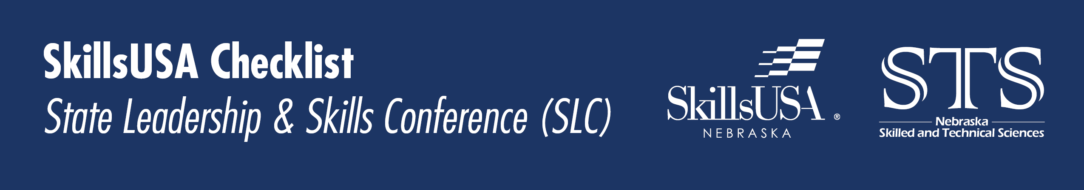

October/November
☐ SLC & contest explanation.
☐ Chapter competition signup/assigned. Chapter SLC contest signup form.
☐ Fundraise for SLC.
☐ Line up mentors for SLC competitions.
☐ Begin practicing for SLC competitions.

December
☐ Reserve hotel rooms.
☐ Check in with students on how preparation for SLC is going.
☐ Check in with mentors on how preparation for SLC is going.

January
☐ *Finalize chapter membership registration.
☐ Register for SLC, registration general opens early January.
☐ Check in with students on how preparation for SLC is going.
☐ Check in with mentors on how preparation for SLC is going.
☐ Line up mentors for SLC competitions.
☐ Begin practicing for SLC competitions.
☐ Seriously, you haven’t reserved hotel rooms, do it now?

February
☐ National Membership Registration Due February 15th
- Only register students for contests offered on the Contest Eligibility Guide.
- Contestants must be PAID National members to be able to register for State.
- While February 15 is the last day to register members, SkillsUSA Nebraska strongly recommends completing membership registration by the end of January. If members are not added to the national registration by February 15th, then they CANNOT participate in state or nationals.
☐ Fill out academic achievement awards (1st semester grades),
deadline early March.
☐ Fill out Outstanding SkillsUSA Advisor nomination form (It’s not comfortable tooting your own horn but do it). Deadline early March.
- Email application to greg.stahr@nebraska.gov
- Visit website for Award Form.
☐ Advisor service pin, deadline early March.
- Fill out google application form Visit SLC website for Award Form.
☐ Jake Duncan Outstanding Leadership Award deadline early March.
- Email application to greg.stahr@nebraska.gov
- Visit website for Award Form.
☐ $500 state scholarship application, deadline early March.
- Email application to greg.stahr@nebraska.gov
- Visit website for Award Form.
☐ State officer candidate application, deadline early March.
- Email application to greg.stahr@nebraska.gov
- Visit website for Award Form.
☐ Responsibility release & chapter permission form, deadline early March.
- Email application to greg.stahr@nebraska.gov
- Visit website for Award Form.
☐ Hotel reservations, options are getting very limited by now!

March
☐ Print & Pay Invoice:
Send invoice and check payable to SkillsUSA Nebraska to:
Grafton Associates Attn: Denise Winters
5935 S 56th Street, Ste A
Lincoln, NE 68516
☐ Submit scholarships, awards, nominations listed in February to dos.
☐ Hotel reservations, you snooze you lose!

April
☐ Have with advisor at SLC Medical Release, Personal Liability,
Code of Conduct, Photo/Sound Release.
☐ Attend SLC!

